Case 1-Eur-Czech Republic-Dolní Věstonice-Wishbone Venus

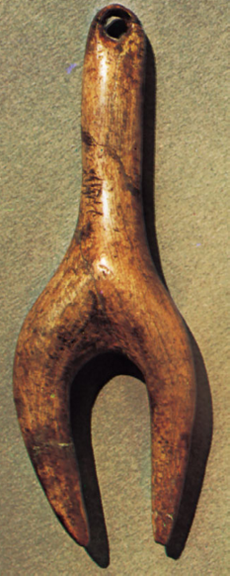
Formal Label: Venus, Czech Republic, Dolní Věstonice, Mikulov, Moravia
Accession Number:
LC Classification:
Date or Time Horizon:
Geographical Area:
Cultural Affiliation:
Media:
Dimensions:
Weight:
Condition:
Provenance:
Discussion:
References:

, Czech Republic; in the Moravian Museum, Brno, Czech Republic. Height (left) 8.3 cm and (right) 8.6 cm.

